Physics 30 1998 June
Use the following information to answer the next three questions.

Roller-Coaster Ride
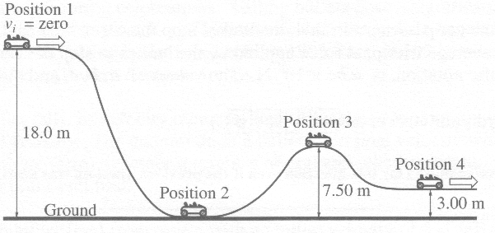
A 250 kg roller-coaster car starts at position 1 and continues through the entire track. The brakes are applied after the car passes position 4. Assume that the effects of friction on the roller-coaster car are negligible between positions 1 and 4.

Numerical Response

- When placed in order from greatest amount of kinetic energy to least, the order of the four different positions of the roller-coaster car labelled on the diagram is ____, ____, ____, and ____.

(Record all four digits in the numerical-response section on the answer sheet.)

- The roller-coaster car's speed at position 4, immediately before the brakes are applied, is
A. 18.8 m/s
B. 17.2 m/s
C. 13.3 m/s
D. 12.1 m/s

Use your recorded answer from Multiple Choice 1 to answer Numerical Response 2. *

Numerical Response

- After the car passes position 4, the brakes stop the car in 3.03 s. The magnitude of the average frictional force applied by the brakes to stop the car, expressed in scientific notation, is a.bc x 10^{d} N. The values of a, b, c, and d are _____, _____, _____, and _____ .

(Record all four digits in the numerical-response section on the answer sheet.)

*You can receive marks for this question even if the previous question was answered incorrectly.

- Ruth is diving from a tower 10.0 in above the water. When she is 5.0 in above the surface of the water, her
A. momentum and kinetic energy are about equal
B. velocity is half of the velocity she will have when she touches the water
C. potential energy, with respect to the water, and her momentum are about equal
D. potential energy, with respect to the water, and her kinetic energy are about equal

Use the following information to answer the next question.

I. Energy
II. Displacement
III. Mass
IV. Acceleration
V. Force

- Which of the above terms represent scalar quantities?
A. I and III only
B. III and V only
C. I, II, and III only
D. II, IV, and V only

Use the following information to answer the next three questions.

In some parts of the world, it is common for people to shoot firearms straight up into the air during celebrations. Falling bullets pose a significant danger to bystanders. Doctors at King/Drew Medical Center in Los Angeles treated 118 people for falling-bullet injuries from 1985 through 1992, and 38 of these people died. All were random victims.

As a bullet falls, its velocity increases until it reaches a maximum, called terminal velocity. The magnitude of a bullet's terminal velocity will depend on its calibre (size), whether it tumbles or not, and whether it falls nose- or blunt-end first.

A 2.00 g bullet fired from a rifle with an initial velocity of 841 m/s travels straight up and reaches an altitude of 2.80 x 10³ m. As it falls, it reaches its terminal velocity of 210 m/s.

Numerical Response

- The rifle has a mass of 3.80 kg. The recoil speed of the rifle, expressed in scientific notation, is a.bc x 10^{-d} m/s. The values of a, b, c, and d are _____, _____, _____, and _____ .

(Record all four digits in the numerical-response section on the answer sheet.)

- How much energy is lost as a result of air resistance as the bullet rises to its maximum altitude?
A. 54.9 J
B. 652 J
C. 707 J
D. 762 J

- What percentage of energy is lost during the entire flight of the bullet?
A. 98.4%
B. 93.8%
C. 92.2%
D. 87.0%

Use the following information to answer the next two questions.

A 1 000 kg car travelling east at 29.4 m/s on an icy road hits a parked truck that has a mass of 1 500 kg. Immediately after the collision, the car was moving at 20.0 m/s in the direction 20.0º N of E, and the truck was moving at an unknown speed in the direction 45.0º S of E.

- What physics principles do police use to determine the speed of the truck?
A. Conservation of kinetic energy but not conservation of momentum
B. Conservation of momentum but not conservation of kinetic energy
C. Both conservation of momentum and conservation of kinetic energy
D. Neither conservation of momentum nor conservation of kinetic energy

Numerical Response

- The magnitude of the total momentum before the collision, expressed in scientific notation, is a.bc x 10^{d} kg·m/s. The values of a, b, c, and d are _____, _____, _____, and _____ .

(Record all four digits in the numerical-response section on the answer sheet.)

_______________________________

- When a charged particle accelerates in an electric field, there is a decrease in its
A. mass
B. charge
C. kinetic energy
D. potential energy

Use the following information to answer the next question.

A student has learned that the elastic potential energy stored in a spring is determined by the equation E_{p} = ½ kx² where x is the displacement of the spring from its resting (equilibrium) position and k is the spring constant for the spring. She conducts an experiment in which she stretches a spring to different lengths and determines the spring’s elastic potential energy at each length. Using her data, she plots the following graph.

Potential Energy as a Function of the Square of the Extension
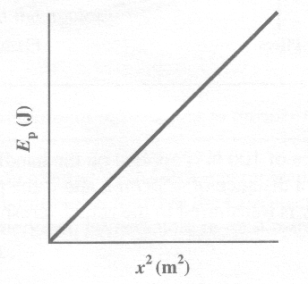

- The student calculates the slope of the best-fit line. What calculation would she have to make to use this slope value to determine the value of the spring constant?
A. Divide the slope by 2.
B. Divide the slope by x².
C. Multiply the slope by 2.
D. Multiply the slope by x².

Use the following information to answer the next four questions.

When a "LifeSaversTM WintOgreen" candy is crushed with pliers in a totally darkened room, a flash of blue light will be observed.
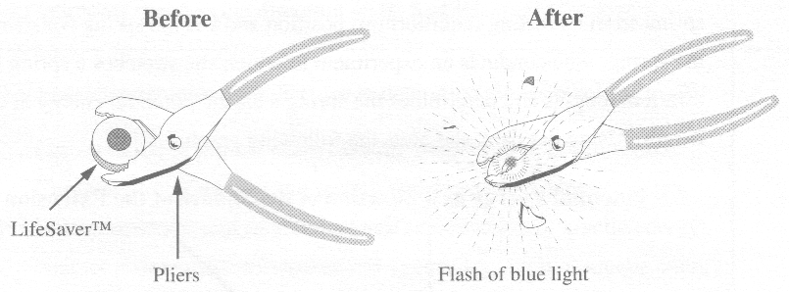

–Hershey Canada Inc.

- If an average force of 100 N is applied on the handles of the pliers, moving them together through a distance of 4.50 mm, and if the pliers are 35% efficient, then how much energy is transferred to the actual "crushing" of the LifeSaversTM candy?
A. 4.5 x 10² J
B. 1.6 x 10² J
C. 4.5 x 10⁻¹ J
D. 1.6 x 10⁻¹ J

Numerical Response

- If the jaws of the pliers exert an average force on the LifeSaversTM candy of 8.50 x 10² N for 1.25 x 10⁻¹ s, then the impulse imparted to the LifeSaversTM candy, expressed in scientific notation, is a.bc x 10^{d} N·s. The values of a, b, c, and d are _____, _____, _____, and _____ .

(Record all four digits in the numerical-response section on the answer sheet.)

Use the following additional information to answer the next question.

As the LifeSaversTM candy is crushed, electrons are released and collide with nitrogen molecules in the air. These collisions cause the nitrogen molecules to emit ultraviolet radiation.

- The emission of an ultraviolet photon from a nitrogen molecule is a result of
A. electron transitions from a lower energy level to a higher energy level
B. electron transitions from a higher energy level to a lower energy level
C. nuclear fusion of the absorbed electron
D. radioactive decay in the nucleus

Use the following additional information to answer the next question.

The ultraviolet radiation emitted by the nitrogen molecules is absorbed by atoms in the oil of wintergreen found in the LifeSaversTM candy. The atoms in the oil of wintergreen immediately re-emit some of this energy as a flash of blue light.

Numerical Response

- The atoms in the oil of wintergreen absorb ultraviolet radiation with a frequency of 8.50 x 10¹⁴ Hz and re-emit blue light with a frequency of 7.50 x 10¹⁴ Hz. The energy difference in the conversion, expressed in scientific notation, is b x 10^{-w} J. The value of b is ____________.

(Record your three-digit answer in the numerical-response section on the answer sheet.)

Use the following information to answer the next question.

Electrostatic Forces
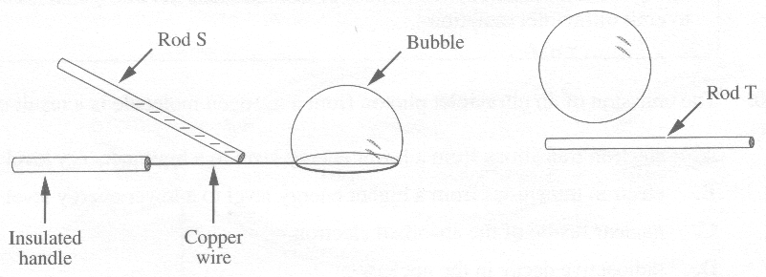
A soap bubble rests on a loop of copper wire. After the wire is touched with negatively charged rod S, the bubble is freed and suspended electrostatically above rod T.

- The bubble is suspended because
A. rod T is negatively charged and repels the negative charges on the bubble
B. rod T is positively charged and repels the positive charges on the bubble
C. the bubble induces a negative charge on rod T and is held up by repulsion
D. the bubble induces a positive charge on rod T and is held up by repulsion
_______________________________

- The relationship between the electrical force, F, on two small, charged objects and their distance of separation, r, is represented by
A. F ∝ r
B. F ∝ 1/r
C. F ∝ r²
D. F ∝ 1/r²

Use the following information to answer the next two questions.

Three charges, q₁, q₂, and q₃, are placed at the vertices of a right angle triangle, as shown below.
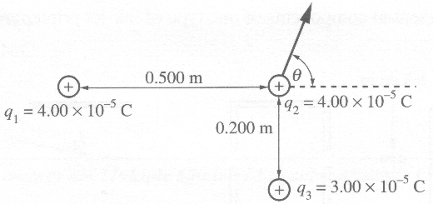

- The magnitude of the net electrostatic force acting on q₂ is
A. 212 N
B. 263 N
C. 276 N
D. 327 N

Numerical Response

- The angle labelled θ indicates the direction of the net electrostatic force on q₂ . The value of θ is ___________º.

(Record your three-digit answer in the numerical-response section on the answer sheet.)

Use the following information to answer the next four questions.

Side View of the Components of an Ink-Jet Printer

The essential components of one type of ink-jet printer are shown below.
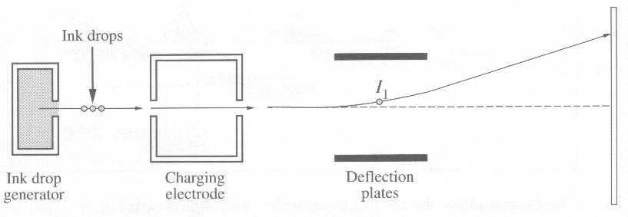
Ink drops from the generator pass through a charging electrode. By means of a signal from a computer, the charging electrode controls the charge given to the ink drops. Ink drops are deflected between the deflection plates. The amount each drop is deflected determines where it strikes the paper. A typical ink drop has a mass of 1.32 x 10⁻¹⁰ kg. Approximately 100 ink drops are needed to form a single letter on paper.

Ink drop I₁ has a charge of –1.51 x 10⁻¹¹ C.

Numerical Response

- The number of excess electrons given to ink drop I₁, expressed in scientific notation, is a.bc x 10^{d} electrons. The values of a, b, c, and d are _____, _____, _____, and _____ .

(Record all four digits in the numerical-response section on the answer sheet.)

- The deflection plates are 0.100 mm apart, and there is a potential difference of 120 V across them. The magnitude of the electric field between the plates is
A. 1.20 x 10⁶ N/C
B. 1.20 x 10³ N/C
C. 1.20 x 10¹ N/C
D. 1.20 x 10⁻² N/C

Use your recorded answer for Multiple Choice 14 to solve Numerical Response 9.

Numerical Response

- As the charged ink drop, I₁, moves through the deflection plates, it experiences a force with a magnitude of, expressed in scientific notation, is b x 10^{-w} N. The value of b is __________.

(Record your three-digit answer in the numerical-response section on the answer sheet.)

*You can receive marks for this question even if the previous question was answered incorrectly.

- To cause ink drop I₁ to follow the path shown, the direction of the electric field between the charged deflection plates must be toward the
A. bottom of the page
B. top of the page
C. right of the page
D. left of the page

- In all circuits that have a constant resistance, the power varies
A. directly as the square of the current
B. inversely as the square of the current
C. directly as the square root of the current
D. inversely as the square root of the current

- Ions, each having a single charge, are accelerated to a given speed. They then enter a magnetic field in a direction perpendicular to the field. The radius of the curved path of each ion is measured. The graph that best shows the relationship between the mass of an ion and the radius of its path is
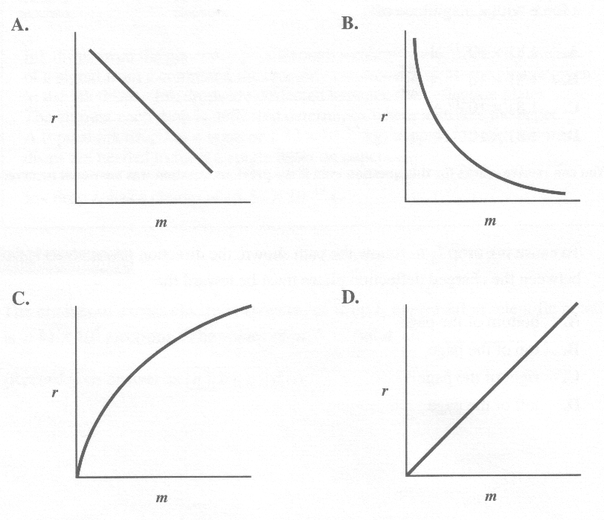

- Magnets can be produced when small magnetic regions in a metal line up their poles. These magnetic regions are called magnetic
A. domains
B. fields
C. atoms
D. areas

Use the following information to answer the next question.

Cross-Section of a Wire Suspended in a Magnetic Field
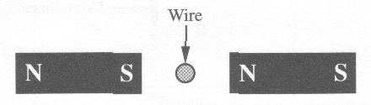
A wire is placed between two permanent magnets. As shown in the diagram, it is positioned so that it is perpendicular to the magnetic field and to the page. The mass of the wire is 0.850 g. The length of the wire perpendicular in the magnetic field is 1.30 cm. The resistance of the wire is 1.20 Ω.

Numerical Response

- When a potential difference of 12.0 V is applied to the wire, there is sufficient magnetic force to keep the wire supported against gravity. The magnitude of the magnetic field, expressed in scientific notation, is a.bc x 10^{-d} T. The values of a, b, c, and d are _____, _____, _____, and _____ .

(Record all four digits in the numerical-response section on the answer sheet.)

Use the following information to answer the next question.

The diagram below shows an experimental design used to investigate the effect of a magnetic field on a vertical current-carrying conductor. The aluminum rod is able to swing freely.
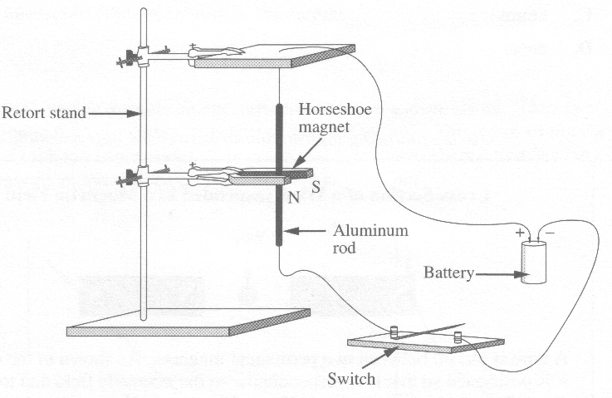

- When the switch is closed, a current in the circuit causes the bottom end of the aluminum rod to swing
A. toward the retort stand
B. away from the retort stand
C. toward the south pole of the magnet
D. toward the north pole of the magnet

- The power line that supplies power to a school has a voltage of 7.20 x 10³ V. The transformer between the school and the line reduces this voltage to 2.40 x 10² V. If an ideal transformer delivers 3.84 x 10³ J of energy every second to the school, then the current in the primary coil of the transformer is
A. 16.0 A
B. 1.88 A
C. 0.533 A
D. 0.0625 A

- Which of the following diagrams illustrates the magnetic field surrounding a bar magnet?

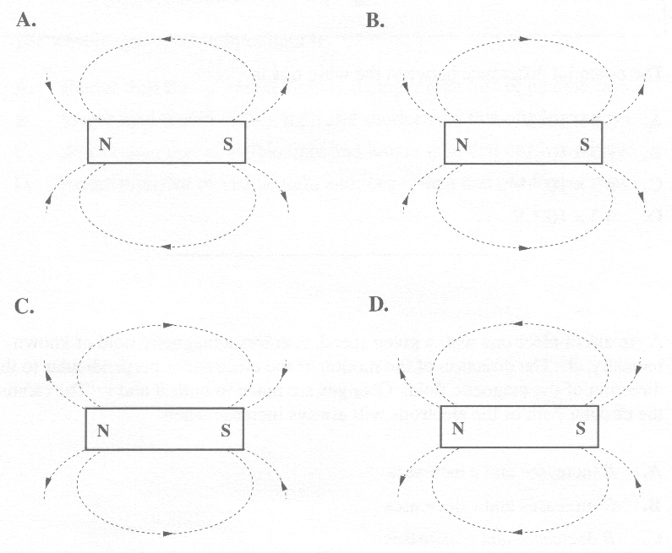
Use the following information to answer the next question.

A plane has a wing span of 15.0 m. While flying directly over the north magnetic pole at 250 km/h, a potential difference is induced between the plane's wing tips. Earth's magnetic field at this position is 6.0 x 10⁻⁵ T and is perpendicular to the path of the plane.
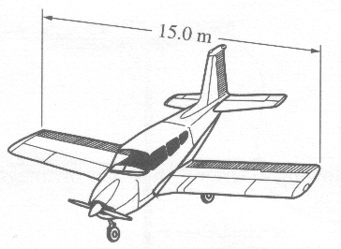

- The potential difference between the wing tips is
A. 2.8 x 10⁵ V
B. 7.7 x 10⁴ V
C. 2.3 x 10⁻¹ V
D. 6.3 x 10⁻² V

_______________________________

- A stream of electrons with a given speed, v, enters a magnetic field of known intensity, B. The direction of the motion of the electrons is perpendicular to the direction of the magnetic field. Changes are made to both B and v. The radius of the circular path of the electrons will always increase when
A. B increases and v increases
B. B increases and v decreases
C. B decreases and v increases
D. B decreases and v decreases

- The north pole of the solenoid shown below is at position
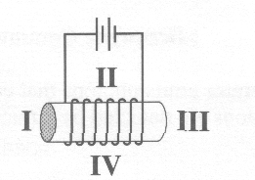
A. I
B. II
C. III
D. IV

- The wavelength of ultraviolet light is
A. shorter than that of visible light and longer than that of gamma rays
B. longer than that of visible light and shorter than that of gamma rays
C. shorter than that of visible light and longer than that of infrared rays
D. longer than that of visible light and longer than that of infrared rays

Use the following information to answer the next two questions.

Microwave Communication

A microwave generator emits photons that each have 4.37 x 10⁻²³ J of energy. Some of these photons are detected by a microwave receiver placed 50.0 km away.
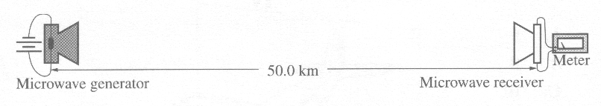

- The time it takes microwave photons to travel from the generator to the receiver is
A. 6.00 x 10⁻⁴ s
B. 5.10 x 10⁻⁴ s
C. 3.33 x 10⁻⁴ s
D. 1.67 x 10⁻⁴ s

Numerical Response

- The frequency of the microwave photons, expressed in scientific notation, is b x 10^{w} Hz. The value of b is __________.

(Record your three-digit answer in the numerical-response section on the answer sheet.)

- Maxwell proposed the theory that an oscillating electric field generates a
A. parallel electric charge
B. constant magnetic field
C. changing magnetic field
D. perpendicular electric charge

Numerical Response

- In a magnetic field with a strength of 5.60 x 10⁻² T, an alpha particle travels in a circular path with a radius of 6.40 x 10⁻³ m. The speed of the alpha particle, expressed in scientific notation, is b x 10^{w} m/s. The value of b is __________.

(Record your three-digit answer in the numerical-response section on the answer sheet.)

- Some cellular phones operate in the 9.0 x 10² MHz band of the electromagnetic spectrum. The energy associated with each photon of this frequency is approximately
A. 1.4 x 10⁻¹⁵ eV
B. 1.4 x 10⁻¹³ eV
C. 3.7 x 10⁻⁸ eV
D. 3.7 x 10⁻⁶ eV

- The property of cathode rays that provides the best evidence to suggest that they are not electromagnetic radiation, is that they
A. are emitted by a variety of cathode materials
B. move between electrodes at high speeds
C. can be deflected by a magnetic field
D. tend to travel in straight lines

- The charge and the approximate diameter of a nucleus may be estimated from
A. alpha particle scattering experiments
B. X-ray diffraction experiments
C. photoelectron experiments
D. cathode-ray experiments

- The minimum frequency of incident radiation required to raise an electron in a hydrogen atom from the ground state to the third energy level is approximately
A. 1.0 x 10⁻⁷ Hz
B. 3.3 x 10⁻² Hz
C. 3.1 x 10¹ Hz
D. 3.0 x 10¹⁵ Hz

Use the following information to answer the next question.

Maximum Kinetic Energy versus Frequency
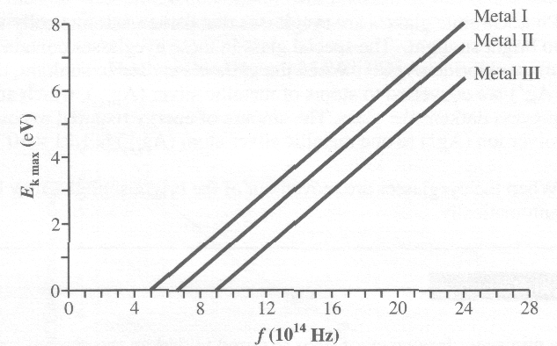
The graph shows how the maximum kinetic energy of photoelectrons depends upon the frequency of the incident radiation for three different metals.

- Which of the metals will emit photoelectrons when illuminated by visible light?
A. I only
B. III only
C. I and II only
D. II and III only

Use the following information to answer the next three questions.

Photochromic Glasses

Photochromic glasses are eyeglasses that darken automatically when exposed to bright sunlight. The special glass in these eyeglasses contains crystals of silver chloride (AgCl). When the glass is exposed to sunlight, the silver ions (Ag⁺) are converted to atoms of metallic silver (Ag _{(s)}), which are dark. This process darkens the glass. The amount of energy required to convert one silver ion (Ag⁺) to one metallic silver atom (Ag _{(s)}) is 1.21 x 10⁻¹⁸ J.

When the eyeglasses are moved out of the bright sunlight, they lighten automatically.

Numerical Response

- The minimum frequency of light required to darken the glasses, expressed in scientific notation, is b x 10^{w} Hz. The value of b is __________.

(Record your three-digit answer in the numerical-response section on the answer sheet.)

- When the eyeglasses are worn indoors, they do not darken. This is because the photons from incandescent bulbs have
A. sufficient energy to convert Cl⁻ ions to Cl atoms
B. insufficient energy to pass through the special glass
C. insufficient energy to continue to convert Ag⁺ ions to Ag atoms
D. sufficient energy to cause photoelectric emission of the Ag atoms

- The type of electromagnetic radiation present in sunlight that is required to darken photochromic glasses is
A. infrared
B. ultraviolet
C. microwave
D. visible light

Use the following information to answer the next two questions.

As artificial elements are created, they are added to the periodic table. In 1982, the 109th element, unnilennium, was created. It was found that unnilennium emits alpha particles as it decays.

Radioactive Decay of Unnilennium
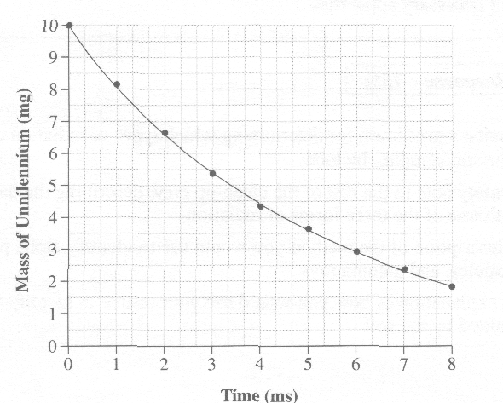

- The nuclear equation describing this decay is
A. 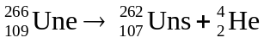
B. 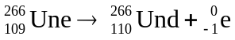
C. 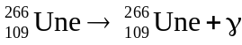
D. 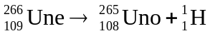

- As determined from the graph, the half-life of unnilennium is between
A. 1 ms and 2 ms
B. 2 ms and 3 ms
C. 3 ms and 4 ms
D. 4 ms and 5 ms

Use the following information to answer the next question.

The diagram below illustrates how a single light fixture is connected to a battery and switch, as might be found in a recreational vehicle (RV).
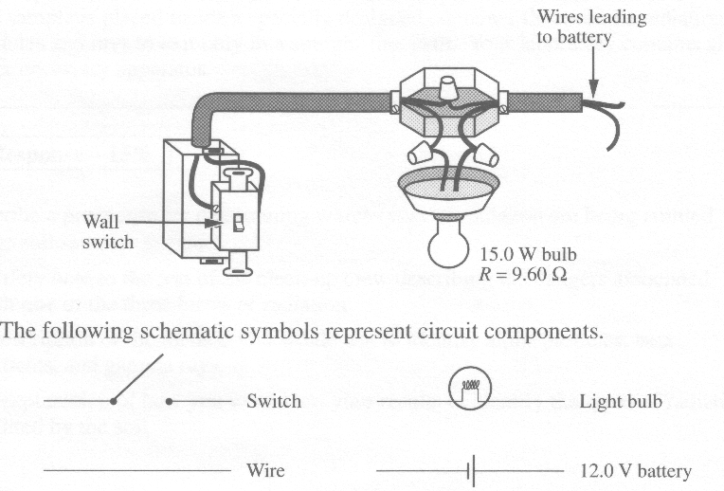

• Using the symbols shown above, draw and label a schematic diagram representing this circuit.

• Draw and label a second schematic diagram containing one switch, the 12.0 V battery, and a 3.0 W nightlight bulb in parallel with the 15.0 W bulb. Design this two-light-bulb circuit so that the switch controls only the 15.0 W bulb.

• Describe what happens to the 3.0 W bulb and the 15.0 W bulb when the switch is open and when it is closed in the two-light-bulb circuit.

• Calculate the total power, total current, and total resistance of the two-light-bulb circuit when the switch is closed.

